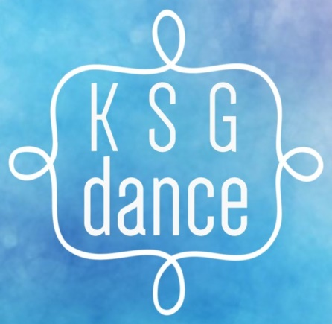
KSG Dance Children’s Party Request Form

Thank you for choosing KSG Dance parties. Our parties include themed games, parachute fun and a short routine taught to the children with the option of putting on a “mini-show” for the grown ups for the last 10 minutes of the session. The birthday child will enjoy 1 hour of fun with their friends with a small birthday gift at the end. Although we do not offer catering services, you may choose to bring a birthday cake with you or purchase a cake as an add on. Please fill in this form and return to KSGdance.bristol@gmail.com . We look forward to hearing you soon.

Name of Organiser
Email
Name of birthday Child
Age of birthday Child
Preferable date of Party (Weekends and bank holidays only)
Second choice date
Number of children attending (please give an estimate if unknown. Please note siblings of children attending will incur an extra charge should they wish to attend).
Approximate age range of children attending
Theme (if applicable)
Medical notes
Additional information

Add ons
30 minutes extra time | £30
KSG Party bag for 30 guests | £50
Birthday cake | £20

