Class | Age | Location | Day and  Time | Price
Commercial dance | 13 +  All abilities | The Island dance studios  Bridewell Street,  Bristol,BS1 | Tuesdays  5.15- 6pm | £4 per session  6 week booking discount available
Pre primary ballet | 1-5 Years  Reception class children also accepted | TBC- Coming Soon | Saturdays  9.30-10.30 | £4 per session  6 week booking discount available
Zumba | 16 +  All abilities | Anytime Fitness,  The triangle, Clifton  Bristol | Mondays  6-6.45pm | Free to members  £5 non-members  Call Anytime fitness to book
Early Stages Performing Arts  (Through Stagecoach Portishead) | 6-8 Years | Gordano School,  Portishead,  Bristol | Fridays  4.45-6.15 | Fees payable to Stagecoach Portishead on a termly basis
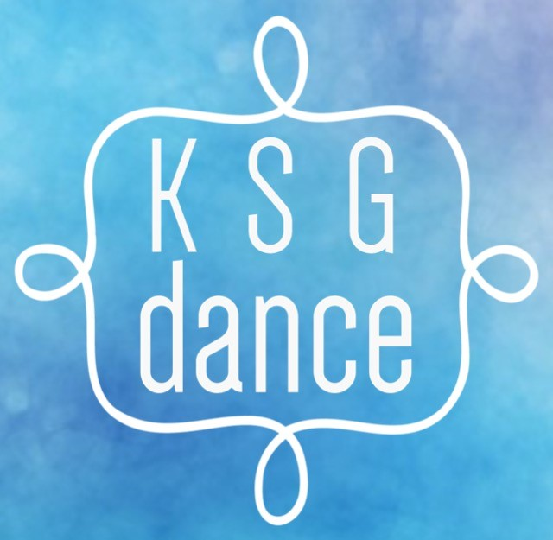

Text your name + age to 07576098298 or call to book your space.
